Zato installation from source code

<https://zato.io/en/docs/3.2/admin/guide/install/source.html>

Install Zato under /opt/zato

code - installation from source codes

env - environments, such as dev, prod, etc

|  |
| --- |
| [(1) Check out the source code from GitHub and enter the newly created directory:](https://github.com/zatosource/) |
| cd /opt |
| git clone https://github.com/zatosource/zato  cd zato/code |
|  |
| (2) Run the installer. If required, it will ask for the password to sudo: |
| ./install.sh |
| (3) Add the bin path:  **export PATH=$PATH:/opt/zato/code/bin**  # adding the path to system restart:  sudo vi ~/.bashrc # saved to home/marvin/  source ~/.bashrc |
| (4) Confirm the installation: |
| ./bin/zato --version |

**Steps to quickly creates a fully operational Zato cluster that can be used for any purposes, from development, testing, up to product production:**

(5) Create a Zato cluster in /opt/zato

**cd /opt/zato**

**zato quickstart ./env/prod1**

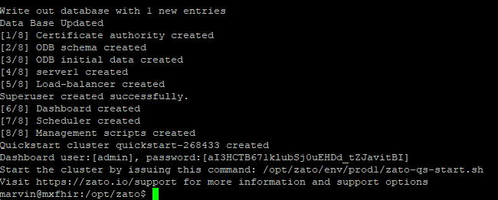

(6) Start the Zato cluster servers:

Run /op/zato/env/prod1/zato-qs-start.sh

(7) The servers can start or stop using zato

|  |
| --- |
| zato start/stop /opt/zato/env/prod1/server1 |
| zato start/stop /opt/zato/env/prod1//server2 # only one server at the moment |
| zato start/stop /opt/zato/env/prod1//load-balancer |

(8) Update password for web admin

zato update password /opt/zato/env/prod1/web-admin admin

new password: 123456